EXP 12
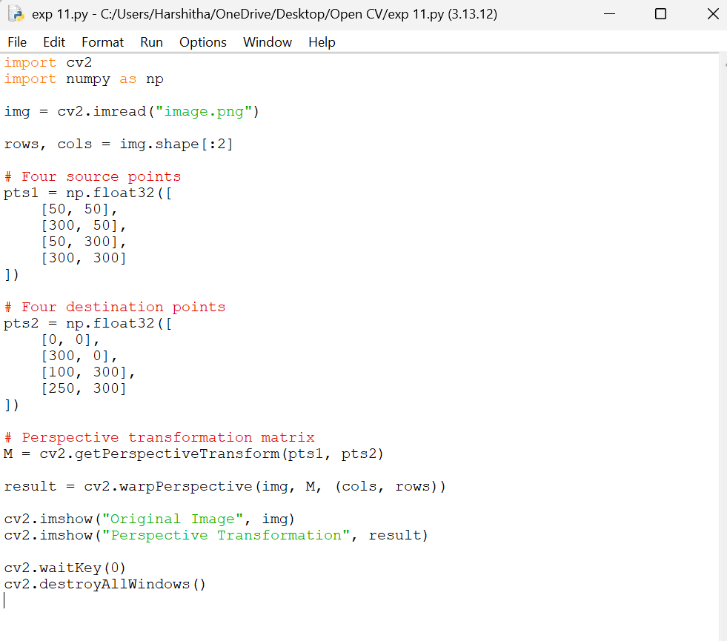
AIM: To perform Perspective Transformation on an image using OpenCV in Python by applying a perspective transformation matrix to change the viewing angle and map the image from one perspective to another.

